**Database Instance Creation & Sample Outputs**

Below is a sample screenshots that show the creation of an Oracle database 12c instance in the remote server from the AWS based on the document “Oracle Database 12.2.0 Installation Step by Step using oracle utility dbca.docx” provided. This section also contain screenshot that shows installation test and the initial backup of the database.

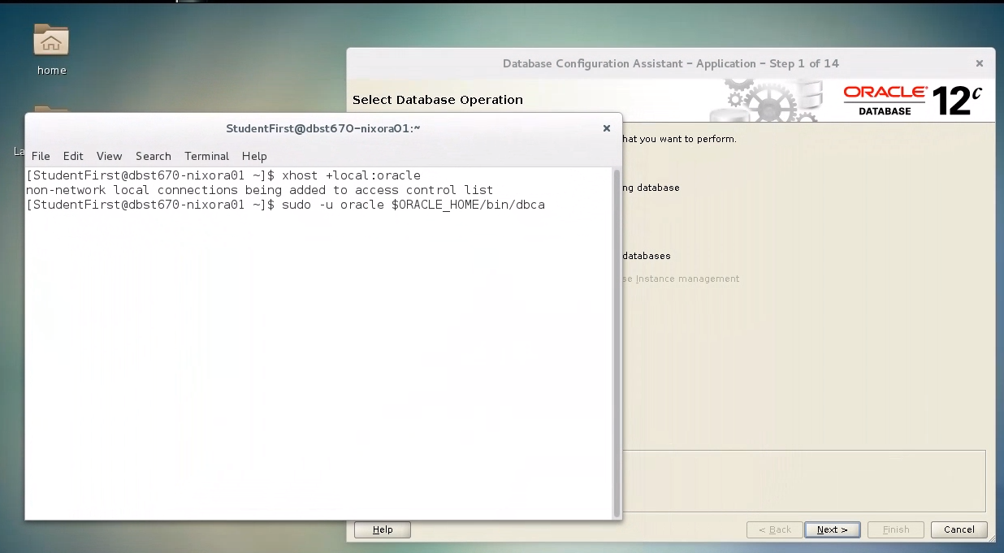

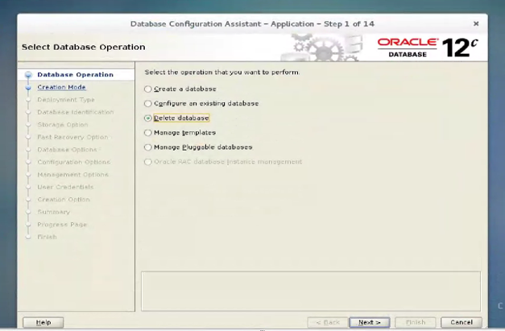

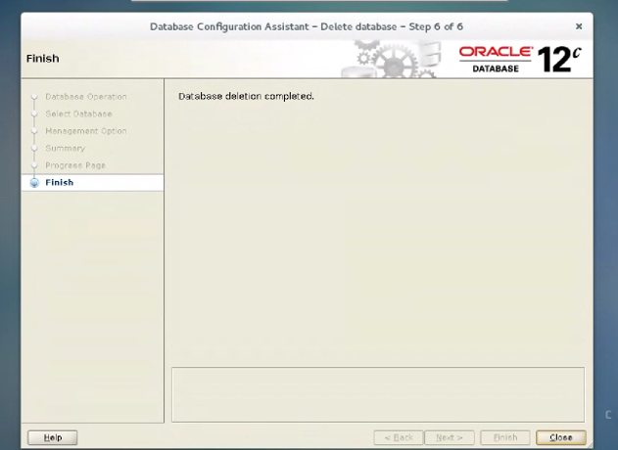

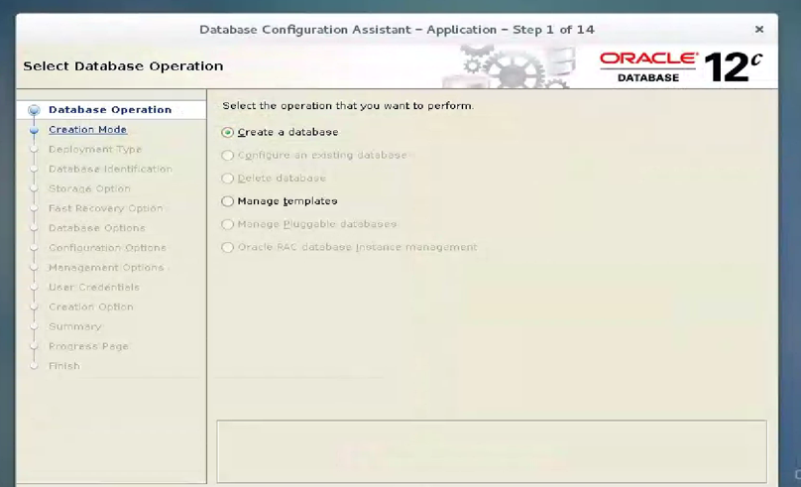

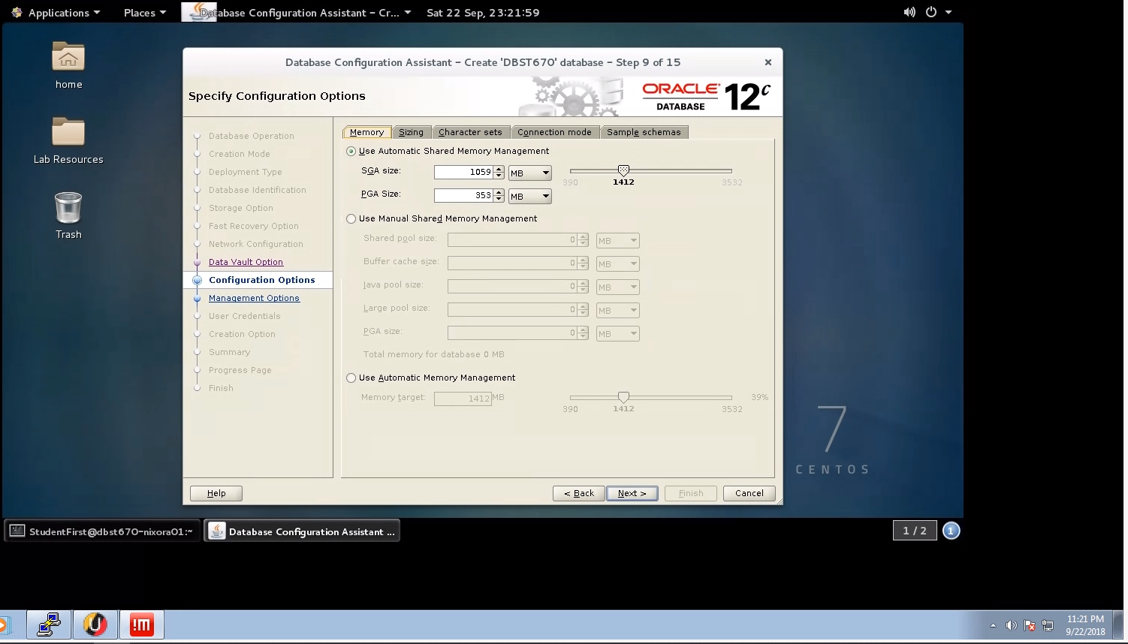

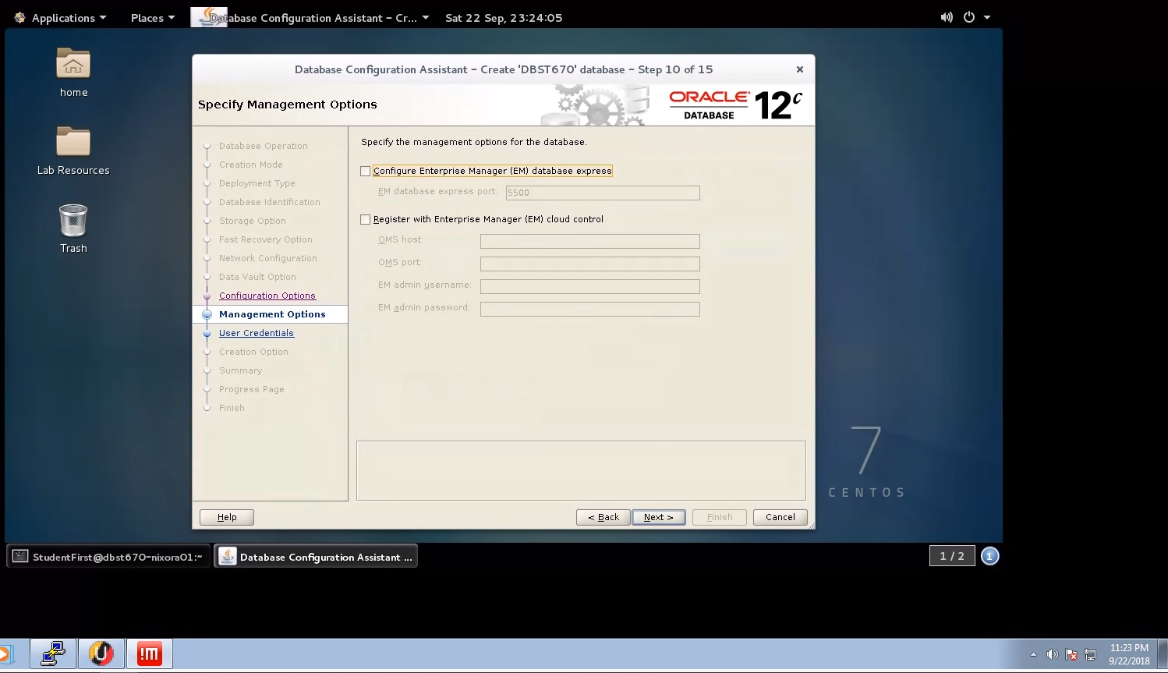

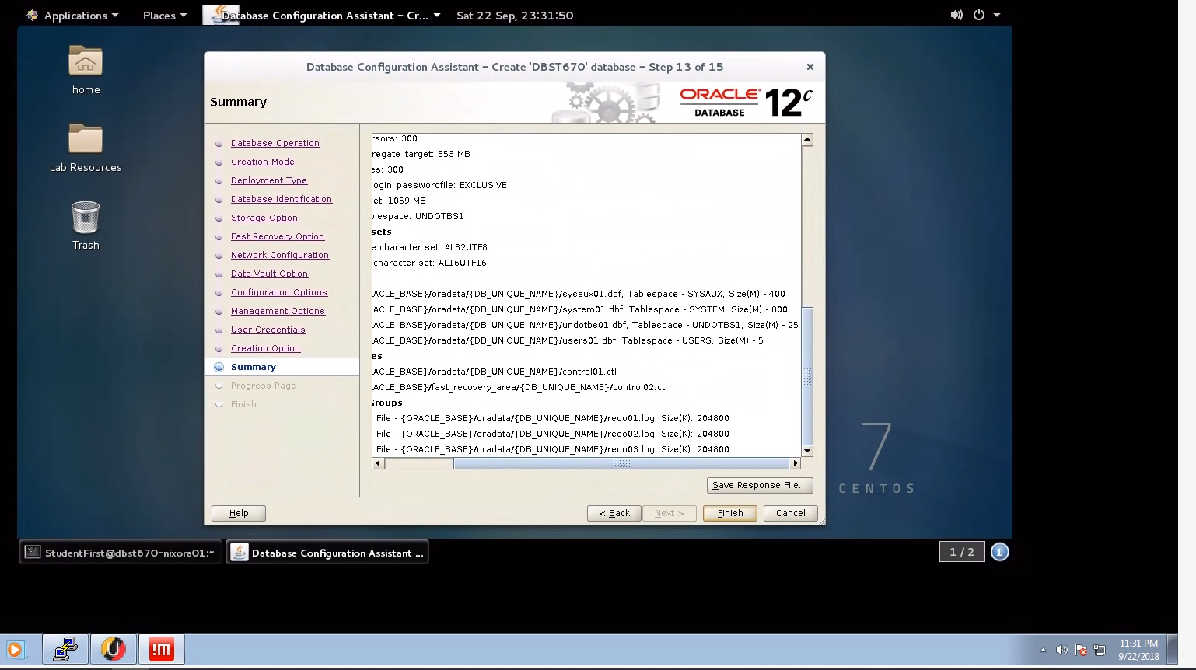

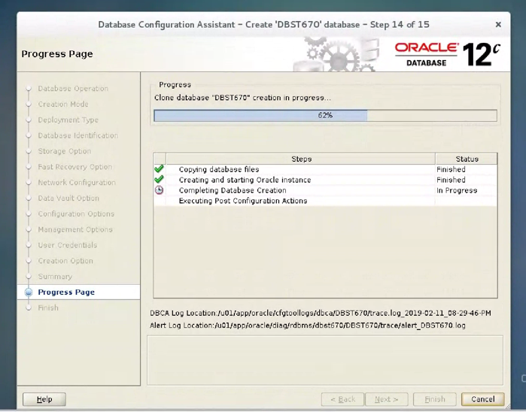

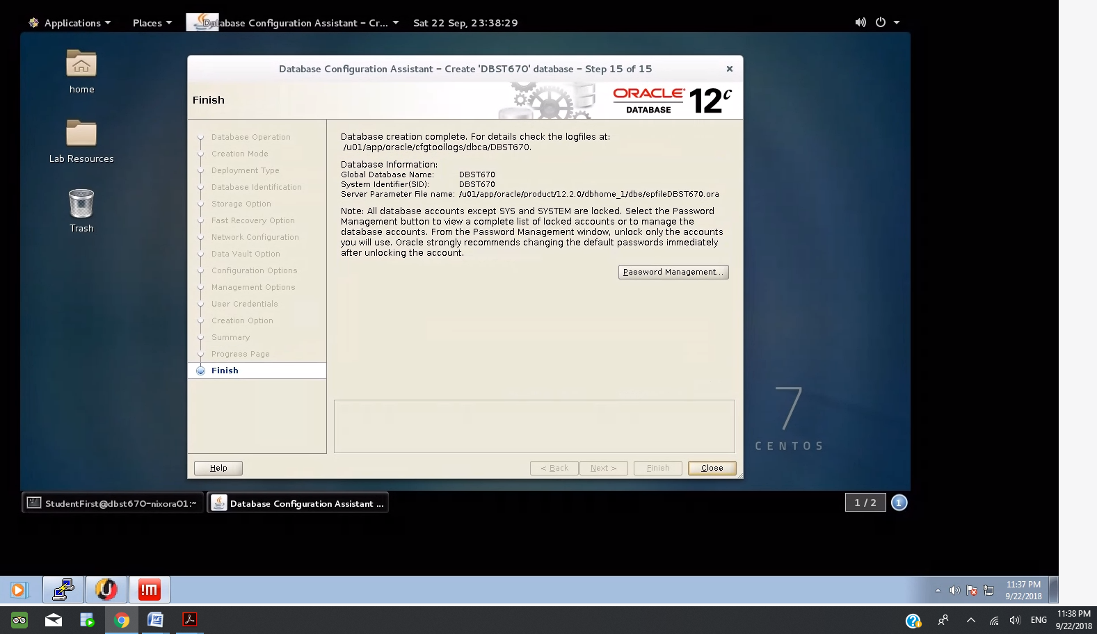

Database instancewas created successfully.

**Installation checkout commands and sample output**

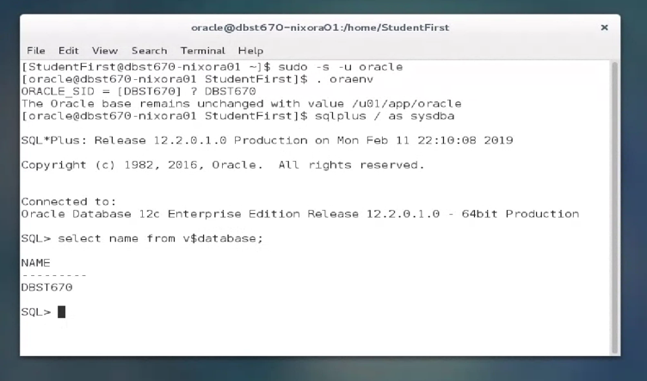

The database instance creation was tested.

Or via PUTTY

The database instance creation was also tested from a Putty session on the AWS.

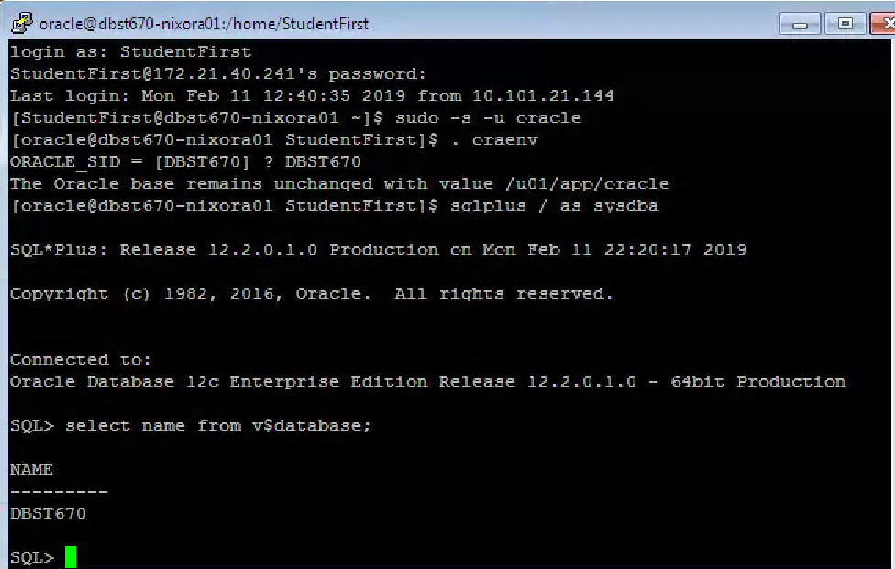

Initial back was performed as follows:

